**PetCare+ –>Specialized Veterinary Treatment Slot Booking System**

**PHASE 4**

**1. Validation Rules**

**What it does:** Prevents users from saving invalid data.  
**What you need:**

* **Slot__c** → Ensure appointment is not booked in the past.
  + Rule: Appointment_Date__c < TODAY() → Error: “Cannot book past slots.”

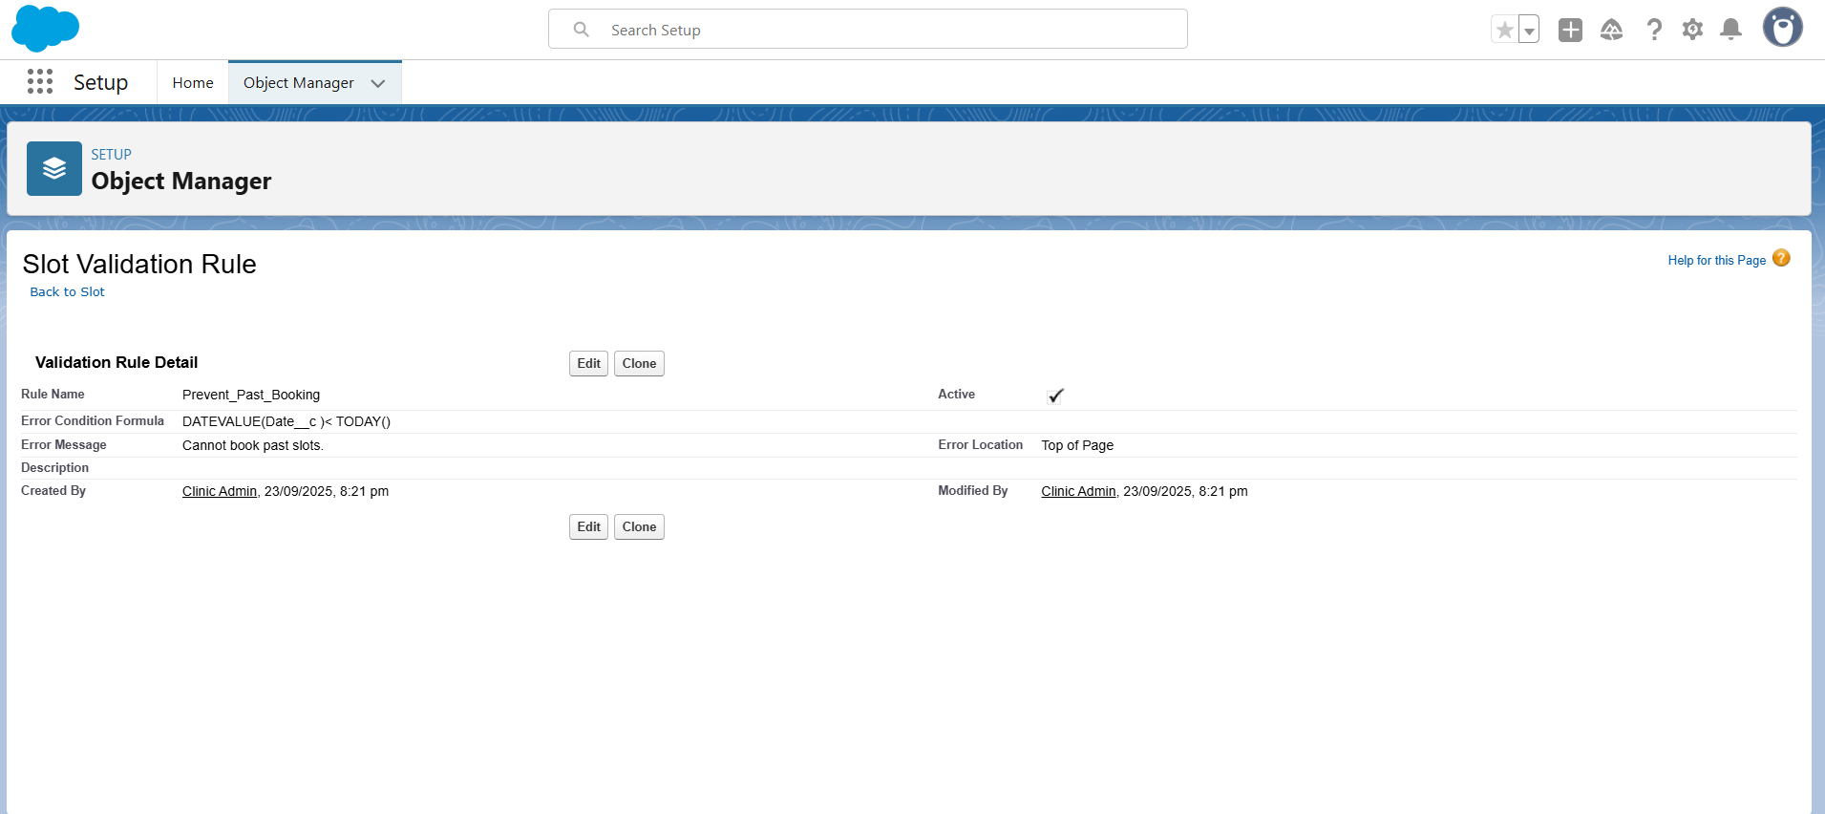

* **Slot__c** → Prevent double-booking for the same doctor & time.
  + Rule: If Doctor = Same AND Time = Same AND Status = “Booked” → Error: “Slot already booked.”  
    **How it helps:** Avoids wrong bookings and ensures only valid slot reservations.

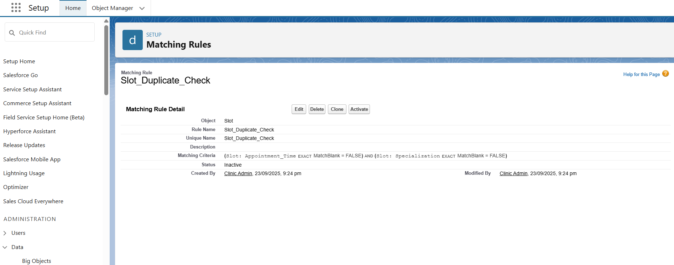

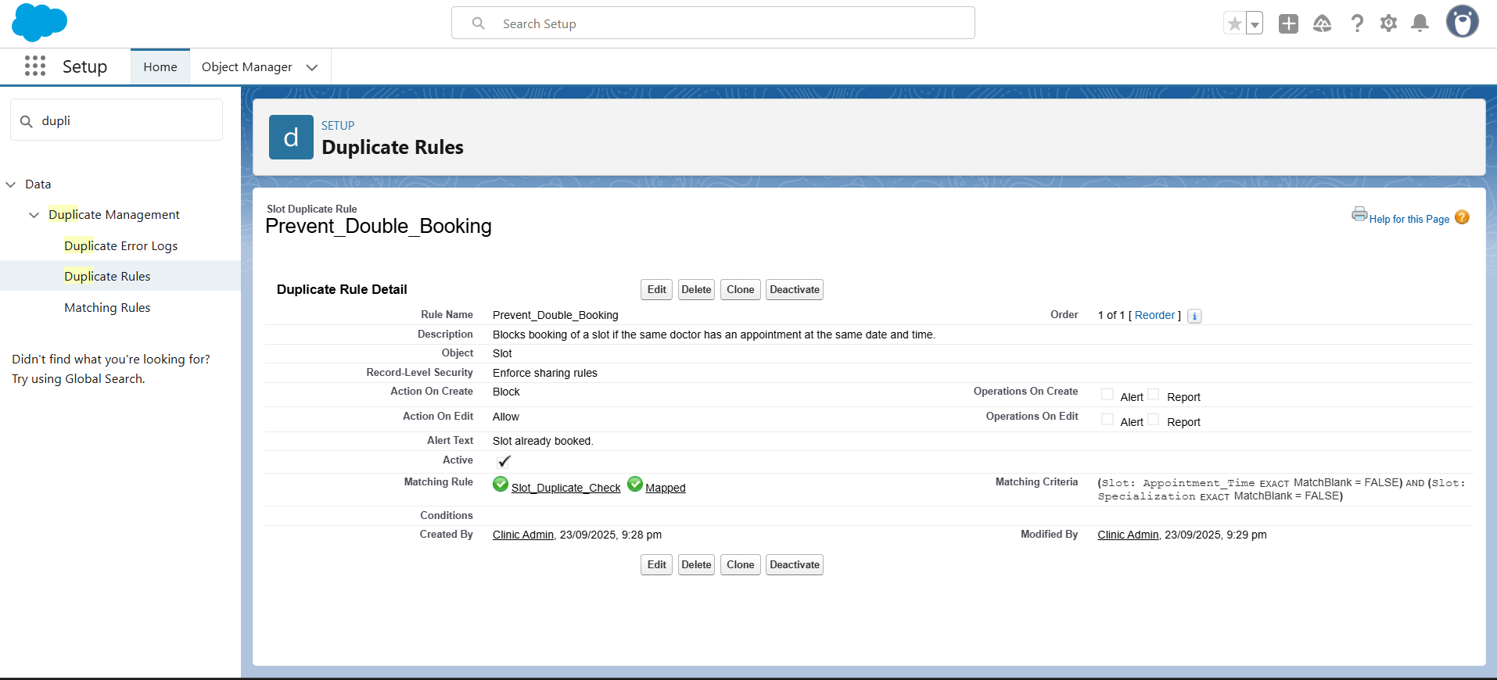

**2.Flow Builder**

* + **Record-Triggered Flow:**
    - When a Slot is booked → automatically set Status__c = "Booked".
    - When a Slot is cancelled → automatically set Status__c = "Cancelled".
  + Auto-launched Flow: Send SMS/email reminders for upcoming appointments.
  + Update Records (Field Updates): Status changes, treatment follow-up updates.

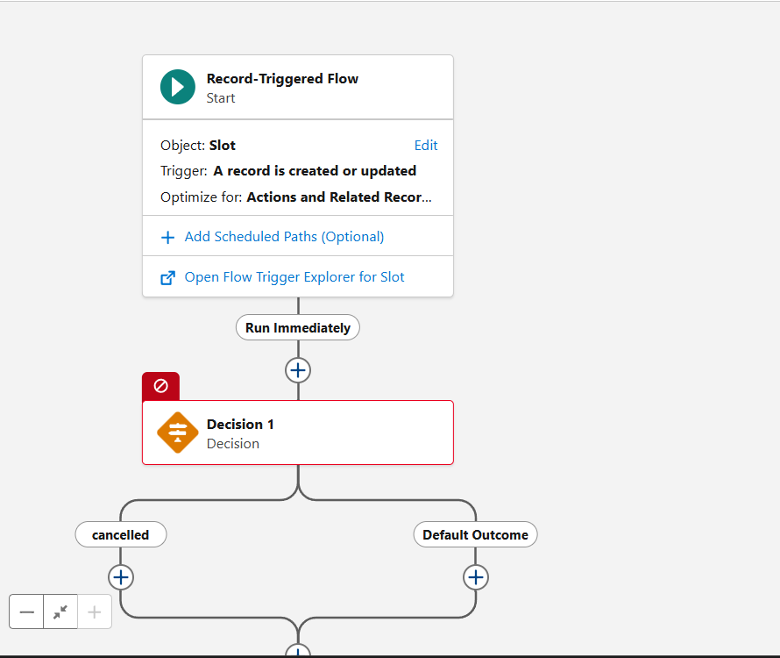

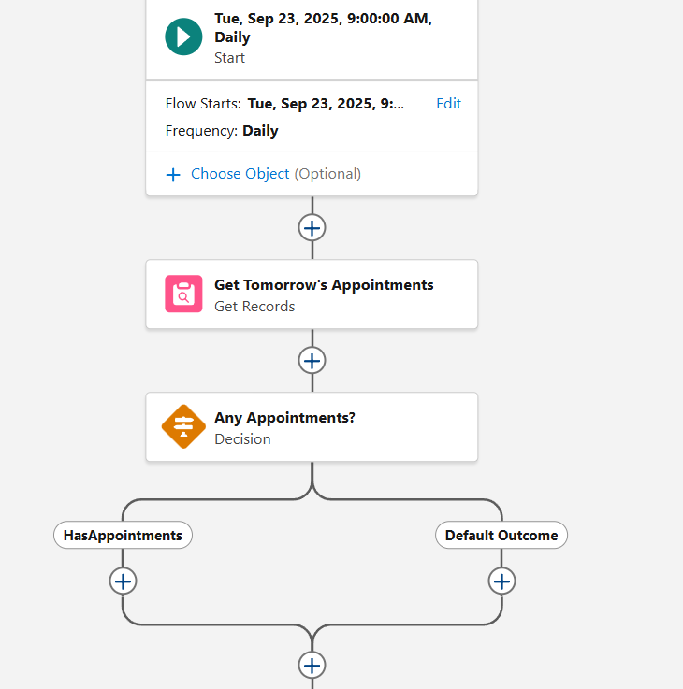

**3. Email Alerts**

**What it does:** Sends predefined email templates.  
**What you need:**

* Email to Pet Owner: Booking confirmation, reschedule, cancellation.
* Email to Doctor: New appointment assigned.  
  **How it helps:** Clear communication to both doctors and pet owners.
* 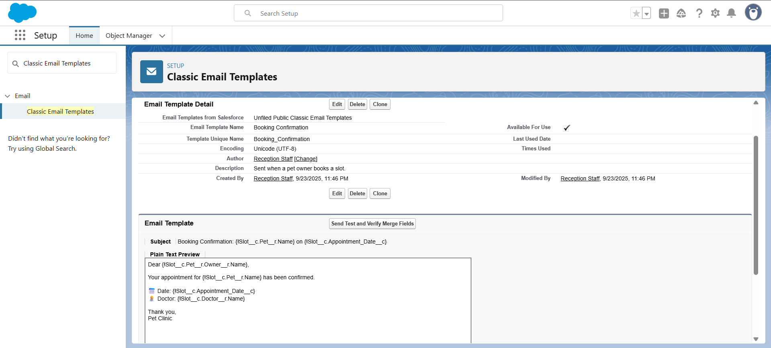
* 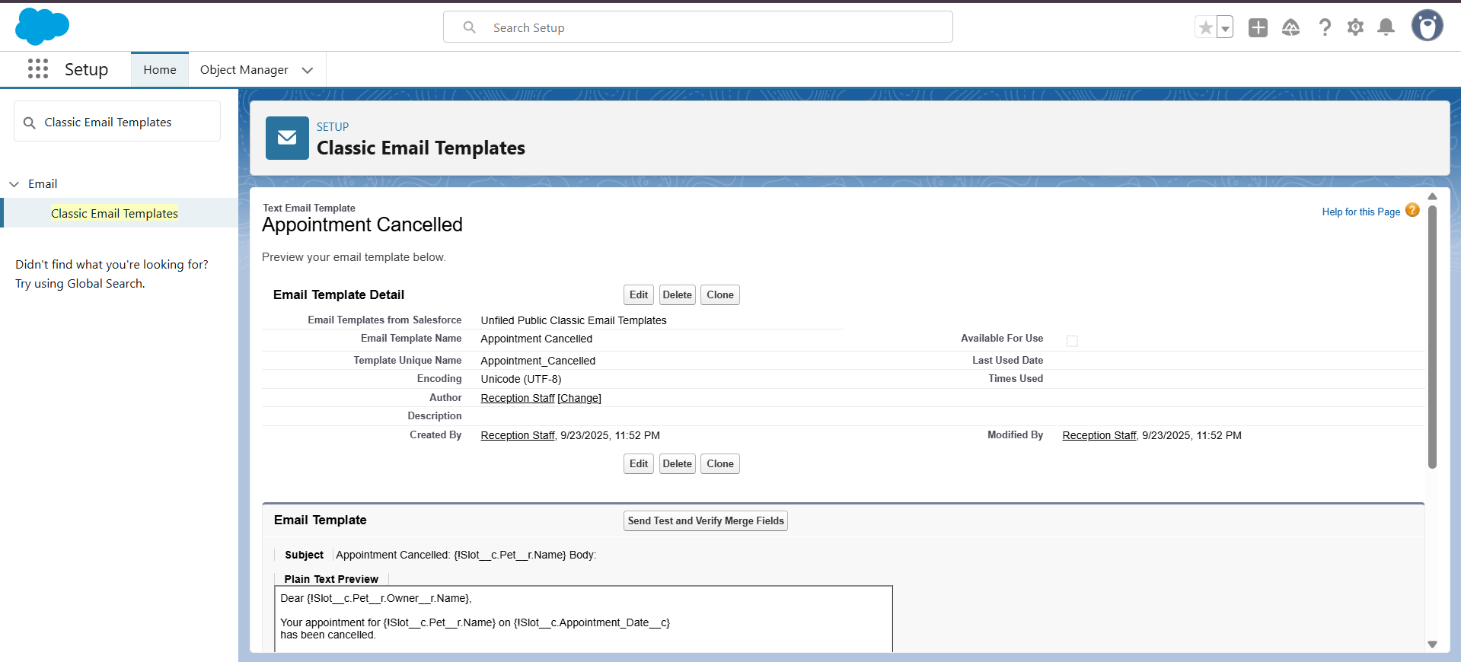

**4. Tasks**

**What it does:** Creates to-do items for users.  
**What you need:**

* Create a **Task for Doctor** when a new treatment is assigned. Example: “Consult pet [Name] at [Time].”  
  **How it helps:** Doctors won’t miss appointments; tasks appear in their Salesforce homepage.

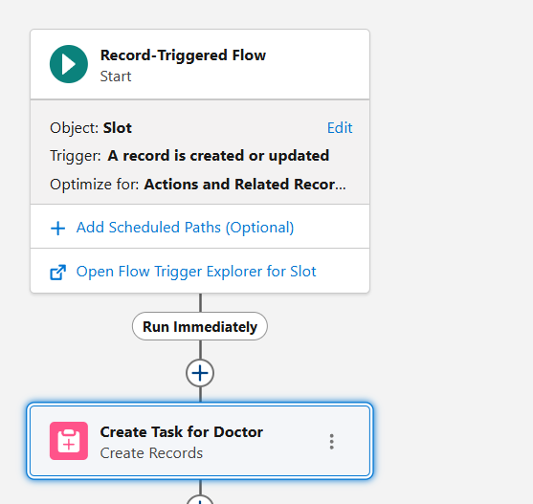

**5. Custom Notifications**

**What it does:** Sends in-app or mobile push notifications.  
**What you need:**

* Notify Doctor instantly when a slot is booked for them.
* Notify Receptionist if a pet owner cancels online.  
  **How it helps:** Faster than email for clinic staff, ensures no missed updates.

